Turing Test in Artificial Intelligence

The Turing test was developed by Alan Turing(A computer scientist) in 1950. He proposed that the “Turing test is used to determine whether or not a computer(machine) can think intelligently like humans”?
The Turing Test is a widely used measure of a machine’s ability to demonstrate human-like intelligence. It was first proposed by British mathematician and computer scientist Alan Turing in 1950.
The basic idea of the Turing Test is simple: a human judge engages in a text-based conversation with both a human and a machine, and then decides which of the two they believe to be a human. If the judge is unable to distinguish between the human and the machine based on the conversation, then the machine is said to have passed the Turing Test.
The Tu ring Test is widely used as a benchmark for evaluating the progress of artificial intelligence research, and has inspired numerous studies and experiments aimed at developing machines that can pass the test.
Imagine a game of three players having two humans and one computer, an interrogator(as a human) is isolated from the other two players. The interrogator’s job is to try and figure out which one is human and which one is a computer by asking questions from both of them. To make things harder computer is trying to make the interrogator guess wrongly. In other words, computers would try to be indistinguishable from humans as much as possible.
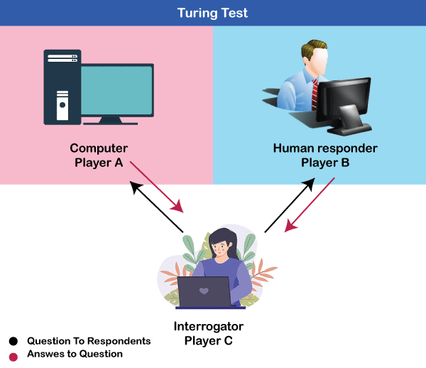
The Turing test is based on a party game "Imitation game," with some modifications. This game involves three players in which one player is Computer, another player is human responder, and the third player is a human Interrogator, who is isolated from other two players and his job is to find that which player is machine among two of them.
Consider, Player A is a computer, Player B is human, and Player C is an interrogator. Interrogator is aware that one of them is machine, but he needs to identify this on the basis of questions and their responses. The conversation between all players is via keyboard and screen so the result would not depend on the machine's ability to convert words as speech.
The test result does not depend on each correct answer, but only how closely its responses like a human answer. The computer is permitted to do everything possible to force a wrong identification by the interrogator.
The questions and answers can be like:
Interrogator: Are you a computer?
PlayerA (Computer): No
Interrogator: Multiply two large numbers such as (256896489*456725896)
Player A: Long pause and give the wrong answer.
In this game, if an interrogator would not be able to identify which is a machine and which is human, then the computer passes the test successfully, and the machine is said to be intelligent and can think like a human.
"In 1991, the New York businessman Hugh Loebner announces the prize competition, offering a $100,000 prize for the first computer to pass the Turing test. However, no AI program to till date, come close to passing an undiluted Turing test".

Advantages of the Turing Test in Artificial Intelligence:
- Evaluating machine intelligence: The Turing Test provides a simple and well-known method for evaluating the intelligence of a machine.
- Setting a benchmark: The Turing Test sets a benchmark for artificial intelligence research and provides a goal for researchers to strive towards.
- Inspiring research: The Turing Test has inspired numerous studies and experiments aimed at developing machines that can pass the test, which has driven progress in the field of artificial intelligence.
- Simple to administer: The Turing Test is relatively simple to administer and can be carried out with just a computer and a human judge.

Disadvantages of the Turing Test in Artificial Intelligence:
- Limited scope: The Turing Test is limited in scope, focusing primarily on language-based conversations and not taking into account other important aspects of intelligence, such as perception, problem-solving, and decision-making.
- Human bias: The results of the Turing Test can be influenced by the biases and preferences of the human judge, making it difficult to obtain objective and reliable results.
- Not representative of real-world AI: The Turing Test may not be representative of the kind of intelligence that machines need to demonstrate in real-world applications.

